APPENDIX A
PHOTOGRAPHS TAKEN DURING JIV AT 18” TEBIDABA-BRASS PIPELINE AT KAMBORO COMMUNITY, SOUTHERN IJAW L.G.A, BAYELSA STATE ON 3RD MAY, 2024.
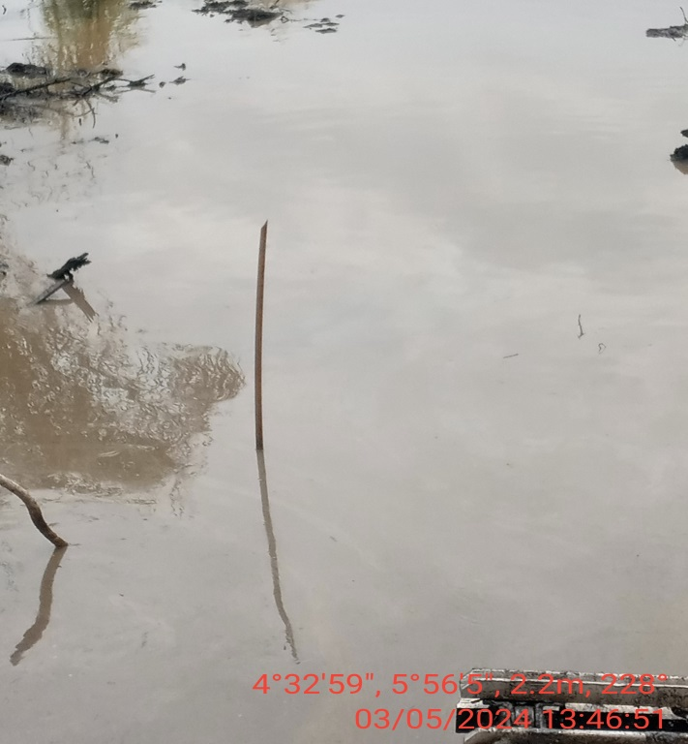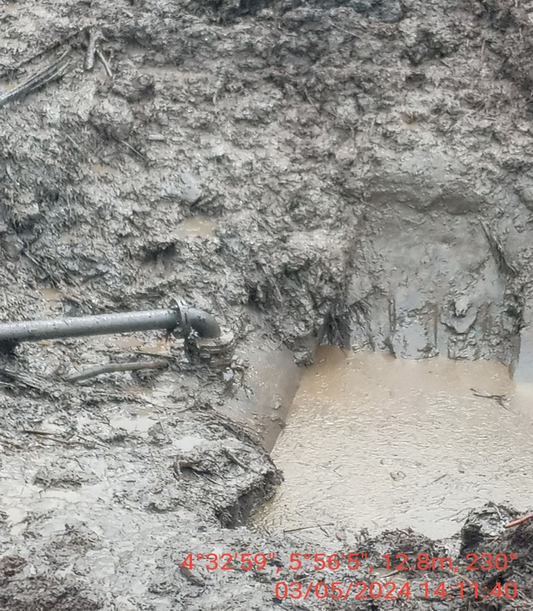
Fig. 1: The incident area before excavation. Fig. 2: 3” valve at 12 o, clock position.
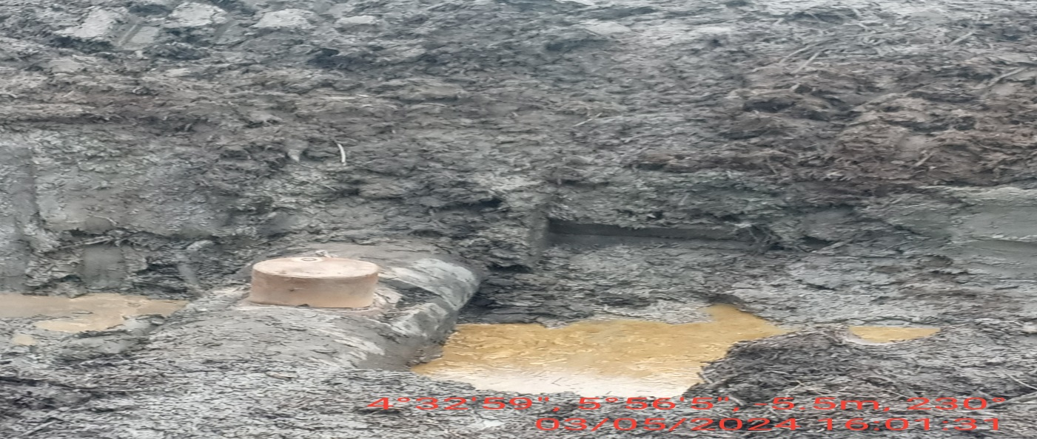
Fig. 3: The incident point after repair has been done.

